19/07/2023

Education Standards Board

SharePoint / Record Point

Not Processing Records

# Issue Noted

* Record Numbers are not showing for records in SharePoint

# Discovery

**SharePoint Site Collections**

Teams Collaboration Site Collection: <http://eecsrsb2019-teams.sa.gov.au/>

Intranet Site Collection: http://eecsrsb2019-sp.sa.gov.au/

**Testing Demo Library**

[DemoLibraryForTraining - All Documents (eecsrsb2019-teams.sa.gov.au)](http://eecsrsb2019-teams.sa.gov.au/Corporate/inform/DemoLibraryForTraining/Forms/AllItems.aspx)

**Testing Current Situation**

* Created new file with the default content type “ESB Core Document” which has the Record Point workflow attached ✅
* Workflow automatically Ran ✅
* Waited a few mins, a “RecordNumber” was not assigned ❌
* Observed that many files are missing RecordNumbers

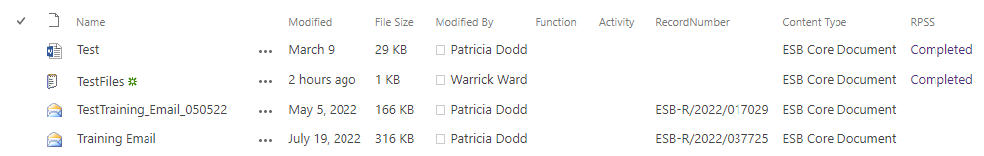

* Workflow ran successfully to add to site Processing Queue

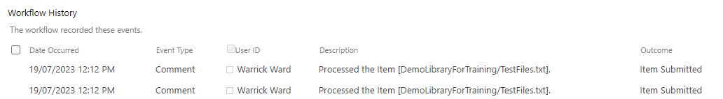

**Record Point Site Settings**

* Site Settings > Record Point > General Settings
  + Use the RecordPoint Web Service for all submissions for this **Site**. Currently **Disabled**
    - Potential Issue ❌

**Viewing Record Summary of Existing Record (With Record Number)**

* HTTP Error: The operation timed out

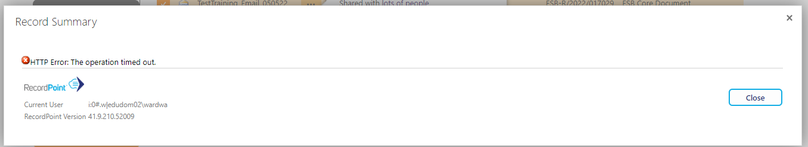

**Mutiple “Record Number” Columns**

* Multiple were discovered in DemoLibraryForTraining ❌
  + RecordNumber – RecordNumber (Some Filled in)
  + Record Number - Record_x0020_Number (All empty)
  + Record Number - Record_x0020_Number1 (All empty)

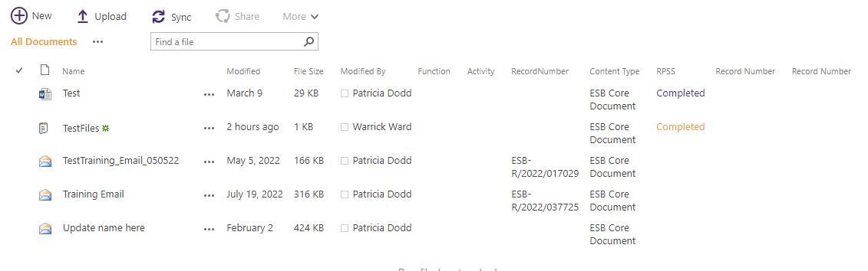

* Only 1 added via Content Type
  + Record Number - Record_x0020_Number (All empty)



* Record Point Configuration with “Record Number” the field being used

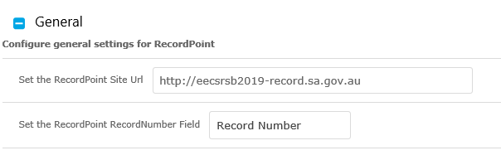

**Content Types**

* No Content Type Hub
  + Deployed to Site Collection
* ESB Core Document
  + Has attached Record Point Submission workflow “RPSS”
  + Had correct starting conditions
* HardCopy Record

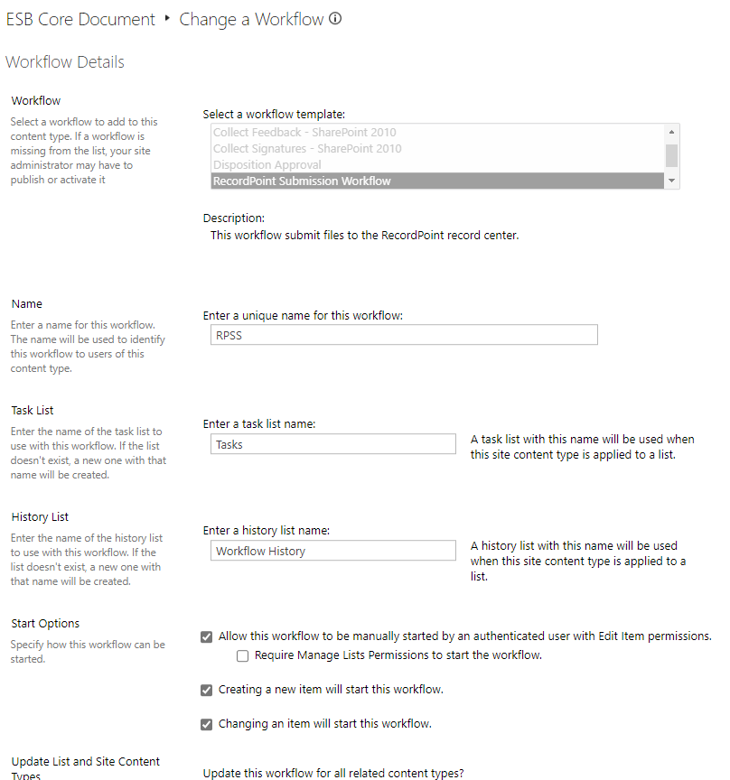

**Health Check Process from Record Point**

<https://recordpointdocumentation.atlassian.net/wiki/spaces/R4/pages/299302913>

* ✅ CPU Usage
  + High consistently, though not causing Record Point Issues ❌
* ✅ IIS Worker Processes
  + Running, level normal
* ✅ SQL Server
  + Content Source locals looks ok, and crawls running
* ✅ Disk Utilisation
  + No Critical Issues
* ✅ Logs
  + No Configuration Issues Observed (Logs not investigated)
* ✅ SharePoint Logs
  + Configuration Issues Observed (Logs not investigated)
* ➖ Event Logs
  + Not Accessible with account
* ➖ Services
  + Not Accessible with account
* ✅ Services on Server (SharePoint)
  + All look ok
* ✅ Deployment of Solutions
  + All look ok
* ✅ Health Analyser
  + Errors notices but not related with Record Point Issues
* ✅ Alternate Access Mapping
  + All look ok
* ❌ Timer Job Check
  + Cannot find any of the following for any sites
    - RecordPoint Active Queue Timer Job
    - RecordPoint Queue Timer Job
    - RecordPoint Daily Tasks Timer Job
* ✅ Search Services Applications
  + All look ok
* ✅ Administrators
  + All look ok
* ✅ Managed Metadata Service Application
  + All look ok
* No Further Checks performed to access Missing Timer Jobs

**Record Point Monitoring Queues**

* Record Point Configuration > Manage Queues
* Observed there are many items in the queue for the Teams site collection not being processes

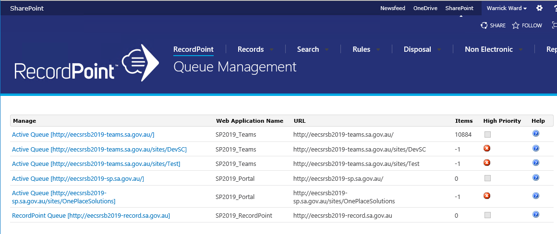

**Record Point Configuration**

* Screenshot of Existing Statistics before resolution

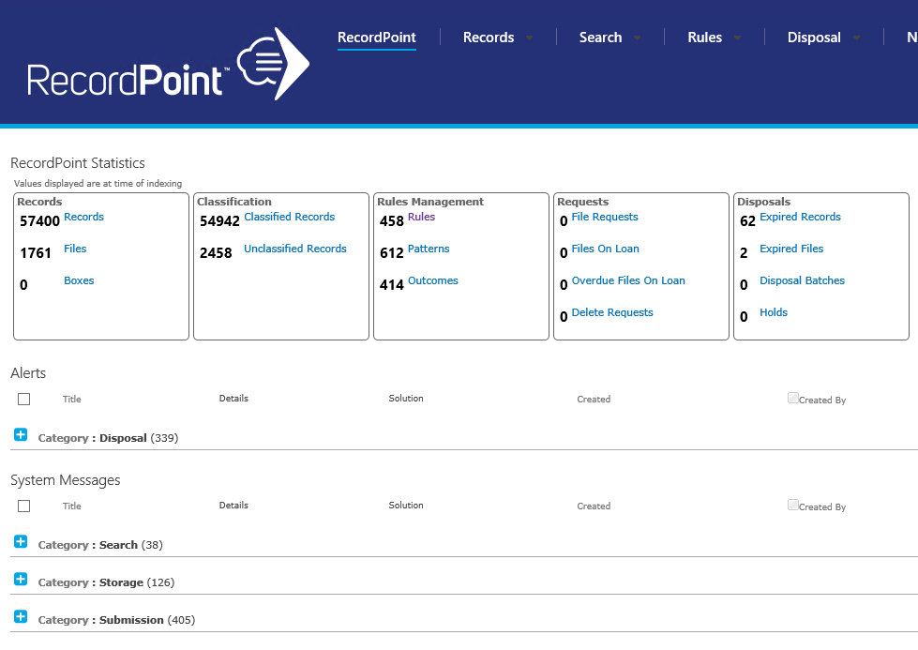

**Investigate Active Queue Timer Jobs**

[Managing RecordPoint Active Queue Timer Jobs - RecordPoint 4.0 - Confluence (atlassian.net)](https://recordpointdocumentation.atlassian.net/wiki/spaces/R4/pages/396248/Managing+RecordPoint+Active+Queue+Timer+Jobs)

* Running the script provided on Record Point support site, ran successfully ✅
* File was produced after running script, with no entries listed ❌

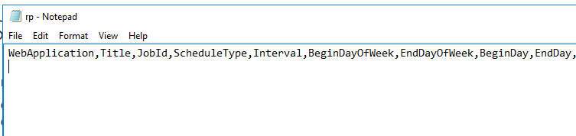

# Issue Identified

* Identified Issue: Missing Record Point SharePoint Timer Jobs
* Timer Jobs should be present in Schedule Jobs list for all Sites, this are missing in the current ESB Instance
* Reference Articles from Record Point Support
  + <https://recordpointdocumentation.atlassian.net/wiki/spaces/R4/pages/299302987/Central+Administration+Checks#Scheduled-Jobs>
  + [What are the different RecordPoint timer jobs and what are they used for? - RecordPoint 4.0 - Confluence (atlassian.net)](https://recordpointdocumentation.atlassian.net/wiki/spaces/R4/pages/76218423/What+are+the+different+RecordPoint+timer+jobs+and+what+are+they+used+for)

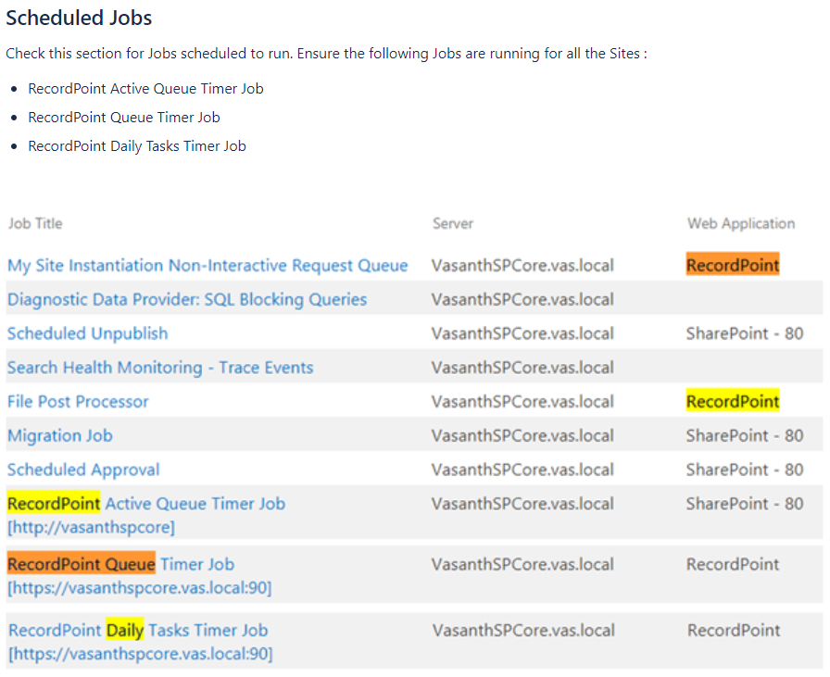

# Resolution

1. Record Point Support Request Raised
2. Support noted missing Timer Jobs
   1. This has occurred in the past, cause by a Major SharePoint Patch being install
3. Support provided script to confirm missing Timer Jobs
4. Support provided script to create missing Timer Jobs
   1. This initially failed with the following errors
      1. New-Object : Cannot find type [RecordPoint.UI.TimerJobs.DisposalTimerJob]: verify that the assembly containing this type is loaded.
      2. The property 'Schedule' cannot be found on this object. Verify that the property exists and can be set.

--- No Fix Currently